Golden Threads: Communication, EHCP Targets, ICT, Functional English/ Maths/ Digital skills
Preparation for Adulthood | Area of focus
Community and Leisure  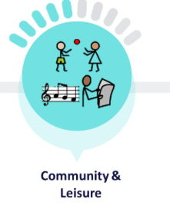 | - Community participation  - Develop own interests  - Exploring Religions and Diversity topics  - British values  - Creativity  - Enrichment opportunities  - Sporting events  - Trips out in the Community, e.g., shops, café, Library  - RSE Lessons  - Maintaining friendships and Relationships
Independent and Supported Living  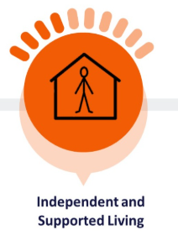 | - Cooking, domestic tasks, preparing drinks, snacks and meals  - Travel training  - Personal safety at home and in the local community  - Shopping skills and money management  - Managing household tasks and daily routines e.g., washing, cleaning, using appliances  - Next steps link work- Preparation for adulthood team
Careers and Enterprise  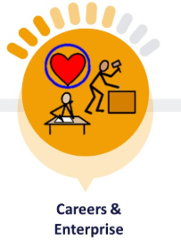 | - Work experience  - World of work  - Next step experiences  - Person centred planning  - Future aspirations and jobs/ volunteering  - Understanding money in relation to work and personal budgets  - Enterprise opportunities  - Encounters with employers and employees  - Encounters with FE and alternative provision  - Experiences with workplaces  - Careers guidance (Next Steps)  - Qualifications Asdan/ Entry Level in Functional skills English, Maths, ICT
Health   | - Learning about a healthy lifestyle  - Healthy eating  - Personal care and hygiene  - The importance of physical activity  - Emotional well-being – Mental Health  - Zones of regulation  - Recognising and assessing health facilities  - Drugs awareness

